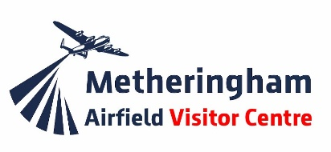
Charity No. 1194347

Dakota Draw 2022

Each ticket costs £1 and any number of tickets can be purchased but please indicate which draw you are buying them for and how many tickets per draw.

The 2022 draws will take place on lecture night 23rd March, 106 Sqn reunion dinner 5th July, MAVC closing day 30th October and at the Trustees meeting on 19th December. Results will be advertised in the ZN News.

50% of the total funds raised per quarter will be paid out in prizes. 1st Prize will be 35% of the 50% 2nd prize will be 15% of the 50%. The balance of the funds raised will be ringfenced for maintenance of the Dakota which is an important and ongoing project.

If you wish to take part, please complete the form below and sent it to
Mrs Janet Guest-Musson, 3 Grantham Road, Navenby, Lincoln LN5 0JJ by post or send via email to treasurer.mavc@gmail.com
. . . . . . . . . . . . . . . . . . . . . . . . . . . . . . . . . . . . . . . . . . . . . . . . . . . . . . . . . . . . . . . . . . . . . . . . . . . . . .
Please enter me for (tick which is applicable)

- March Number of tickets _____ Closing date for entries 14 Mar
- June Number of tickets _____ Closing date for entries 14 June
- Sept Number of tickets _____ Closing date for entries 14 Sept
- Dec Number of tickets _____ Closing date for entries 14 Dec

Total cost at £1 per ticket = _________

Tick below which ever applies

I enclose a cheque payable to Metheringham Airfield Visitor Centre

I have made a transfer to MAVC bank account on (insert date) ___________
Sort Code: 08-92-99 Account: 67221084

Print name _______________________________Membership Number ____________
Address ___________________________________________________________
Postcode ______________________

E mail address _______________________________________________ print clearly
Phone number __________________________

If I win please transfer funds to my bank account as below
Sort code _____________________ Bank account ____________________________

